**Chapter 3**

1. **High Level Design**
   1. 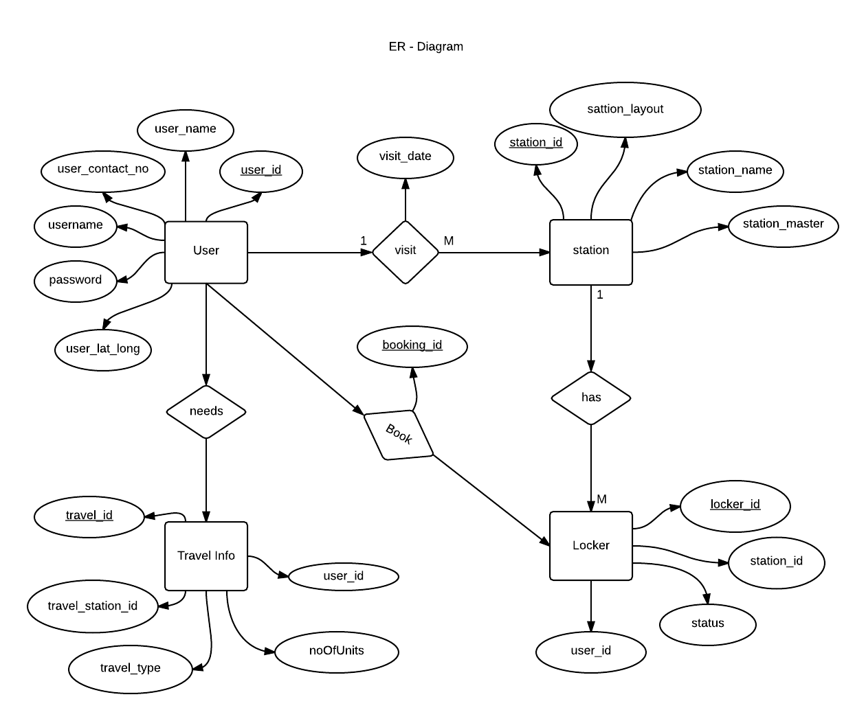Entity Relationship Diagram

DESCRIPTION:

The Entity-Relationship diagram above presents a view of the database used in our Rsil commute system. The database mainly consists of the user information, station and station master information, locker information as well as the train information. This information is updated by the admin in the database. The database consists of variety of linked table that consists of data obtained by the station master about the station. The admin feeds in the other necessary data.

* 1. **Block diagram**

Post Complaint

View Station Layout

View Tourist information

Set Reminder for Destination Station

View Upcoming Station

View notifications

Send Important Notification

View and Update Complaints

Add Station Layout

USER INTERFACE

USER INTERFACE

USER REGISTRATION

PASSENGER

STATION MASTER

DESCRIPTION: The above block diagram presents the view of the features that out system consists. Each block has a feature represents by the other blocks as shown above. There are two kinds of registrations station master which is provided by the admin at the server side and the passenger who registers himself on his android application. The station master has the functionality of providing the station layout, send notifications and view and update the complaints of the passenger. The passenger on the other hand receives these notifications and provides the complaints regarding the train or station. Passenger can view station layout of the upcoming station and the tourist information.

* 1. **Database schema**

This database schema provides the structure of the databases storing the information required.

1. **User Database**

*Database schema and data*

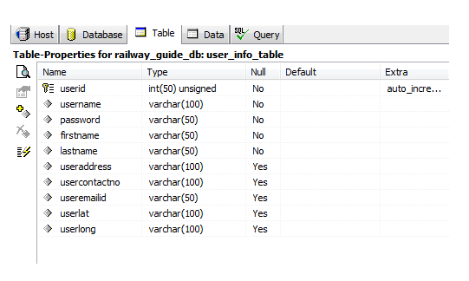



This table stores information about the user that is the passenger who enters these details during registration.

1. 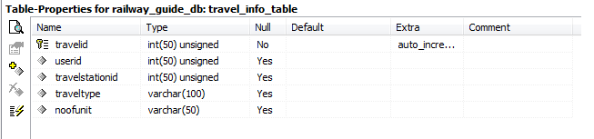**Station Information Table**

*Database Schema and data*

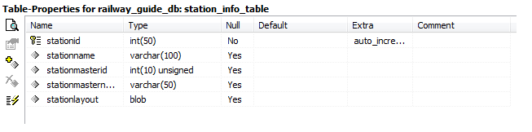

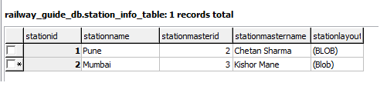

This Table stores the information regarding the station stored by the admin.

1. **Locker Information Table**

*Databse Schema and data*

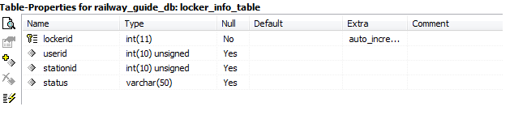

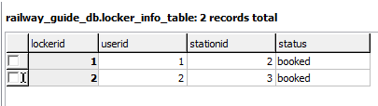

This table stores the record for the lockers booked and available at the particular stations

1. **Station Layout Information Table**

*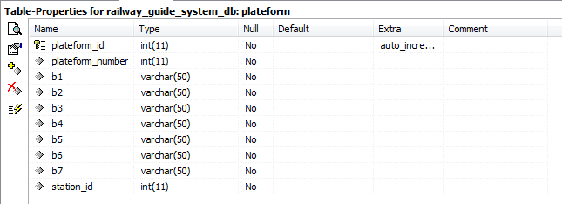Database schema and data*

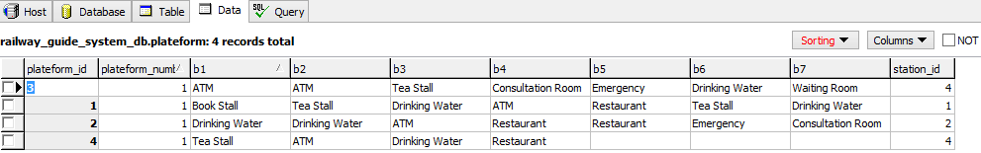

This table is used to store the platform layout set according to the station master of that station.

1. **Station Master Information table**

*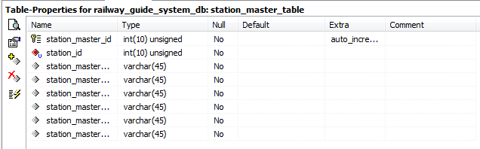Database Schema and Data*

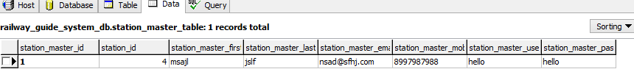

This table stores information about the station master of the stations.

1. **Train Information table**

*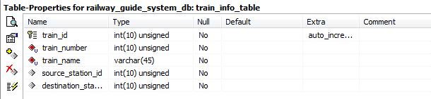Database Schema and Data*

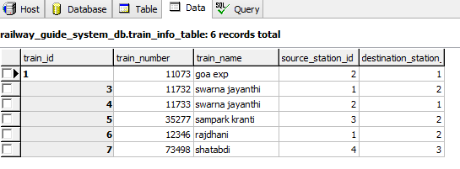

This table consists of the information about the train like the number source station destination station etc.

1. **Train Route Information table**

*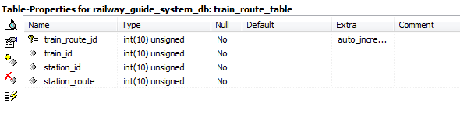Database and data*

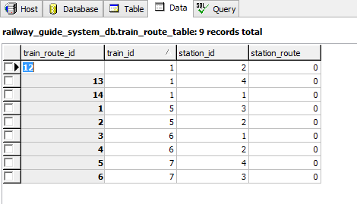

This Table stores the route through which it will pass.it stores all the station ids it will pass through.

1. 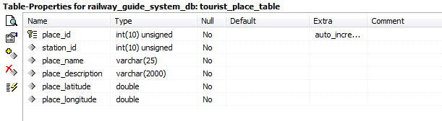**Tourist Place table**

*Database Schema and Data*

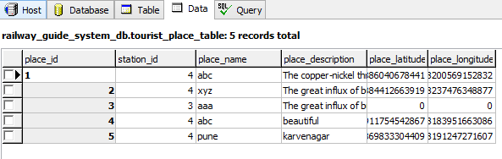

This table stores information about the tourist places of the particular stations.

1. **Admin Table**

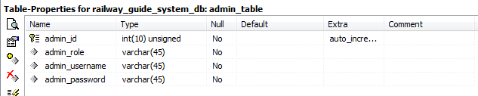*Database Schema and Data*

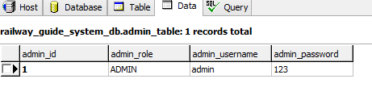

This table stores the login details for the admin.

* 1. 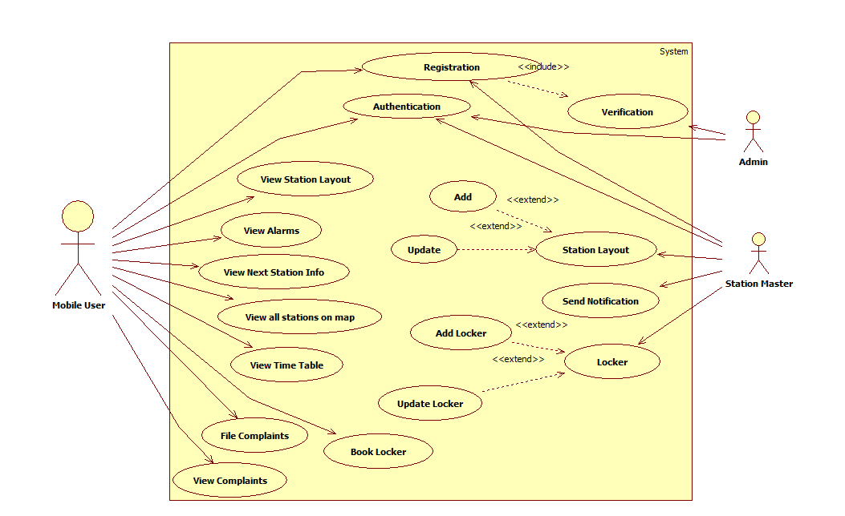**UML diagrams**
     1. **Use Case diagram**

This is a use case diagram for Rail Commute System. The actors here are the admin, station master and the passenger. The admin has the functionality as shown above of registration verification and authentication. The passenger has been provided with the features of the application which he/she can access using the user interface. Station master has the functionality to provide the station layout notification and update the complaints of the passengers.

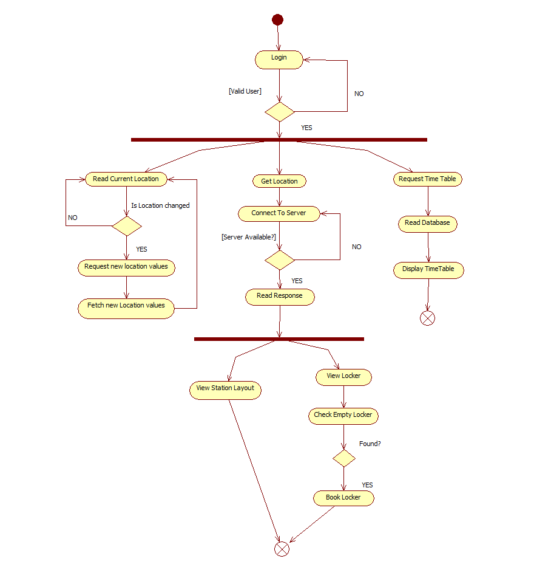

* + 1. **Activity diagram**

The above id an activity diagram of the railway commute system. Activity in our system starts with a login for user as well as admin and station master. After checkin the authentication of the user , the actors perform various functions. The passenger has to be connected to server at all times to access the data like station layout and to receive notifications. The station master and the admin at the server side add the data necessary for the passenger to view.

* + 1. 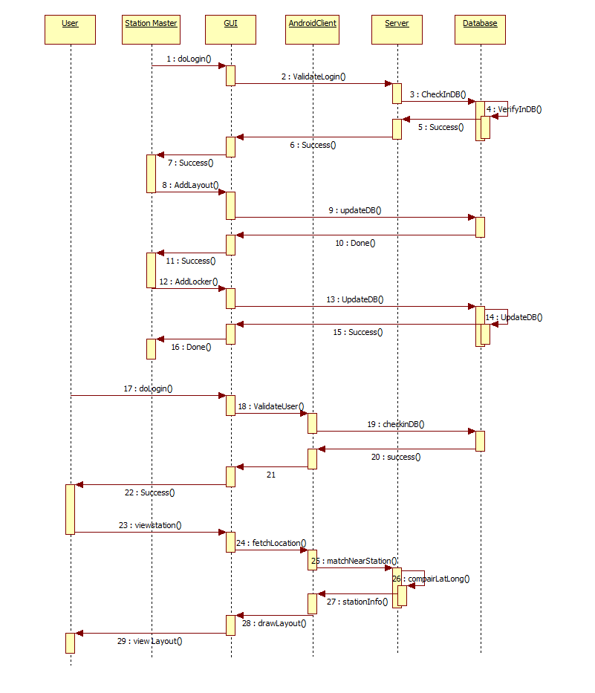**Sequence diagram**

This diagram presents the sequence of events in the system. The event start with the user login then on success() of that event passenger can view nearest station and access other features. The station master can provide the station layout and perform other functions. The admin stores the station by getting it coordinates through the google map api and on comparison to the passenger’s coordinate, the approaching station is notified to him/her and also adds other required informations.

* + 1. **Deployment diagram**

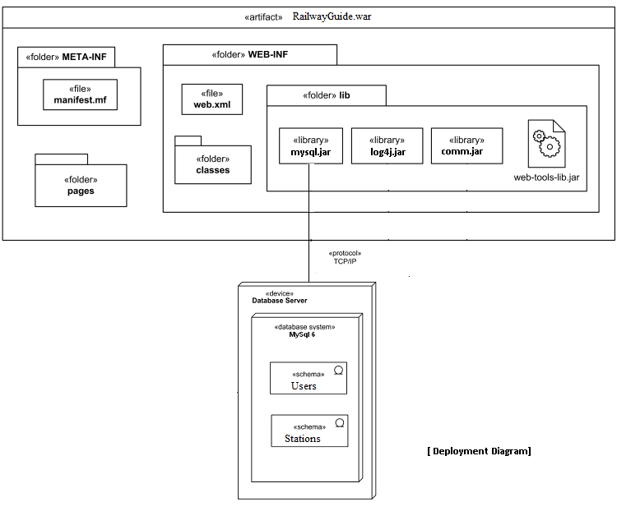

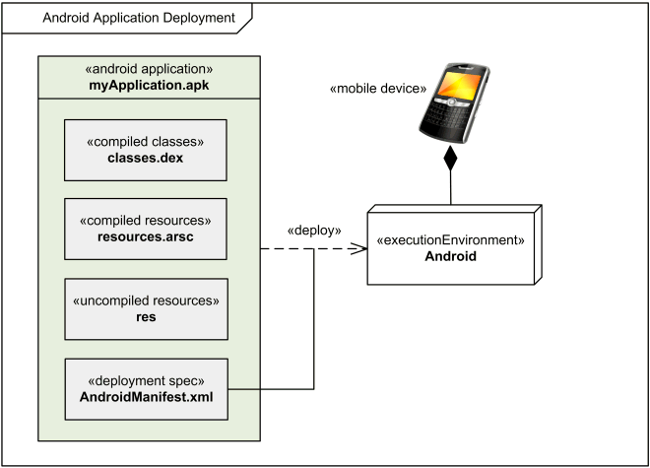

This diagram shows the deployment of our application on the android OS and the tomcat server. It shows the communication of the application with the server side where the admin and station master can access the website and add the required information. The passenger downloads the android APK to access the features of this system.

* + 1. **Package diagram**

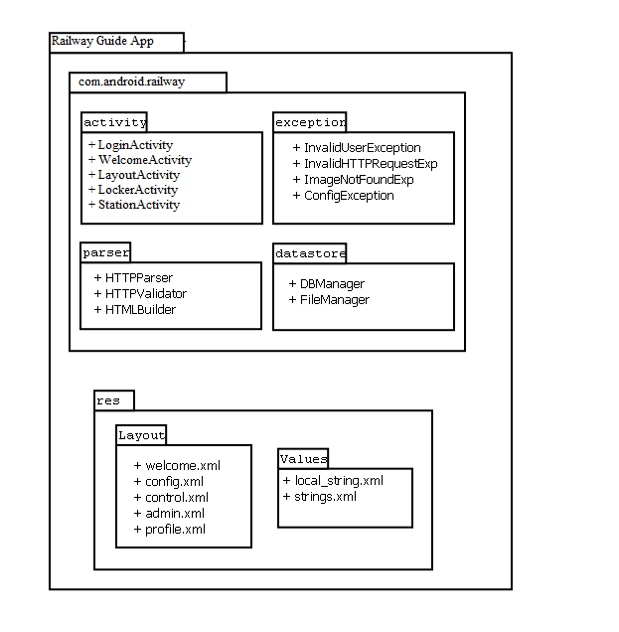

This diagram shows the packages involved in developing this application. The above diagram shows the packages created to store similar type of files together to avoid confusion, reduce time consumption and the code can be viewed easily. The android activity is the client side for the android application. The ‘res’ is the server side for the website to be accessed by the station master and the admin.

* + 1. **Component diagram**

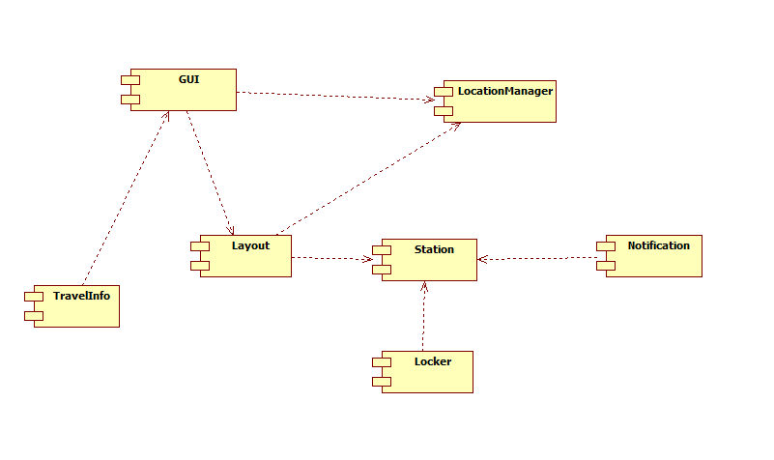

The component diagram shows the components present in the system. GUI is required to access the features of the system by the user. Each Station has a layout, the number of lockers to be booked and the notifications to be sent by its station master.

**3.4.7 Class Diagram**

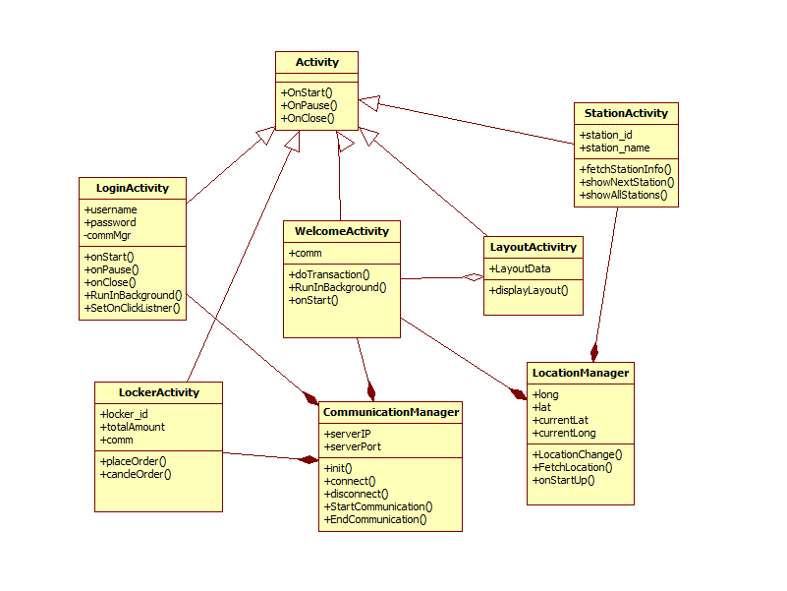

The class diagram shows the classes used in this system. The activity is the main class consisting of all the other activities which inherit its properties. The relationship with the communication and location manager with the particular activities is shown as above.